**Install Visual Studio Code on Ubuntu 22.04**

**Visual Studio Code** is a source code editor developed by Microsoft for Windows, Linux and MacOS operating systems. Debugging, embedded Git control, syntax highlighting, smart code completion/refactoring is an application that lets you build and debug modern web and cloud applications.

In this article, let's examine the installation methods on Ubuntu 22.o4.

**Different methods to Install Visual Studio Code on Ubuntu 22.04**

We will install on Ubuntu with 4 different methods. After reviewing the article, you can continue with the method(s) you want.

**Method-1: Install From Ubuntu Software Centre (From Snap Store)**

Visual Studio Code can be installed with Ubuntu Software Center without using a terminal. Actually, this way of installation is installation from SNAP Store. Ubuntu Software Center pulls the package from the snap store and installs it on the system.

Open Ubuntu Software, type **Visual Studio Code**,

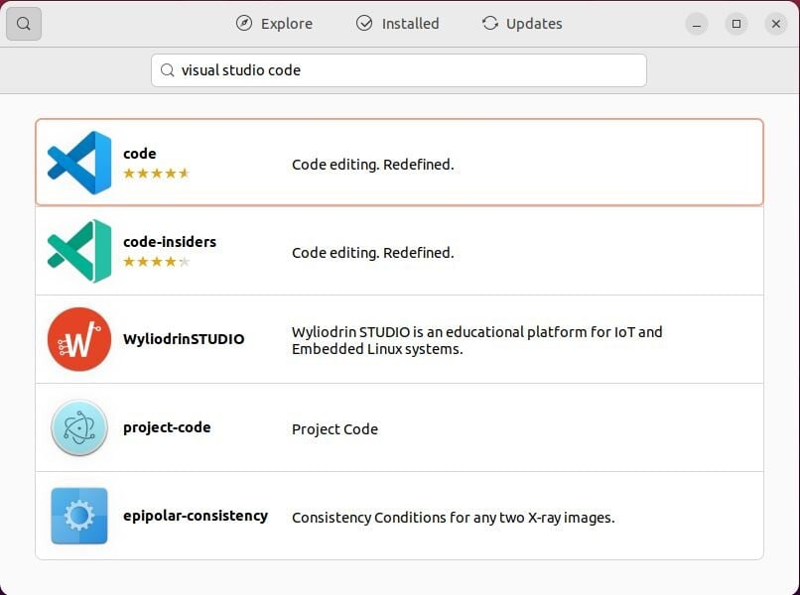

Click the **install** button on the screen that appears.

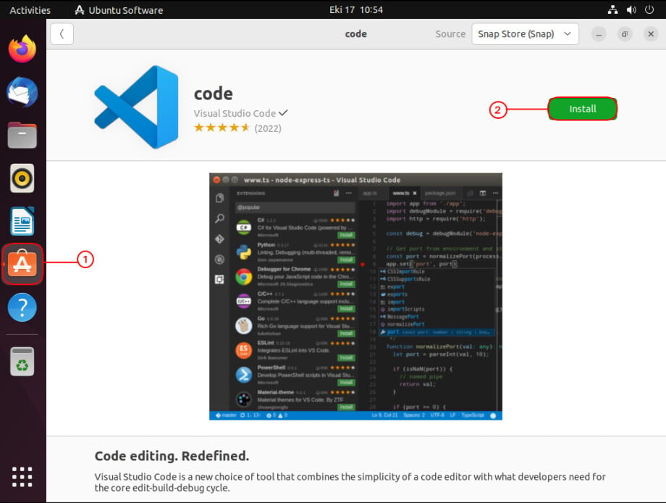

The software installation process is done with the authorized user, continue by entering your password.

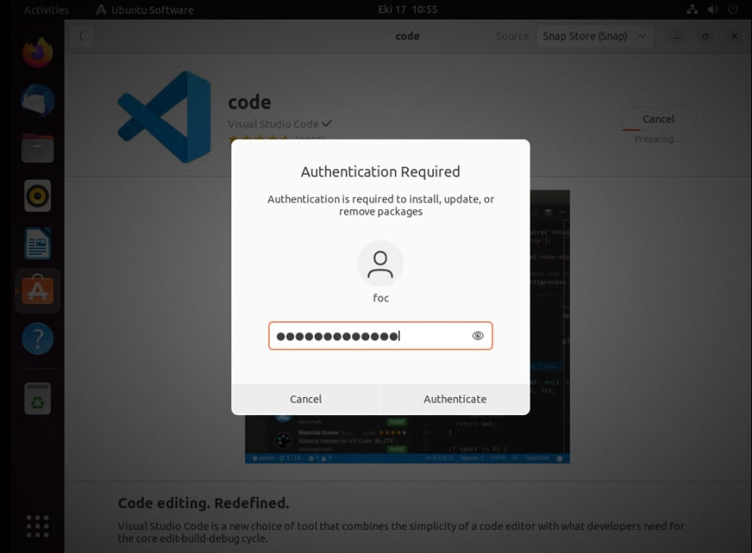

Installation is completed in a few minutes depending on your internet speed.

Advertisement

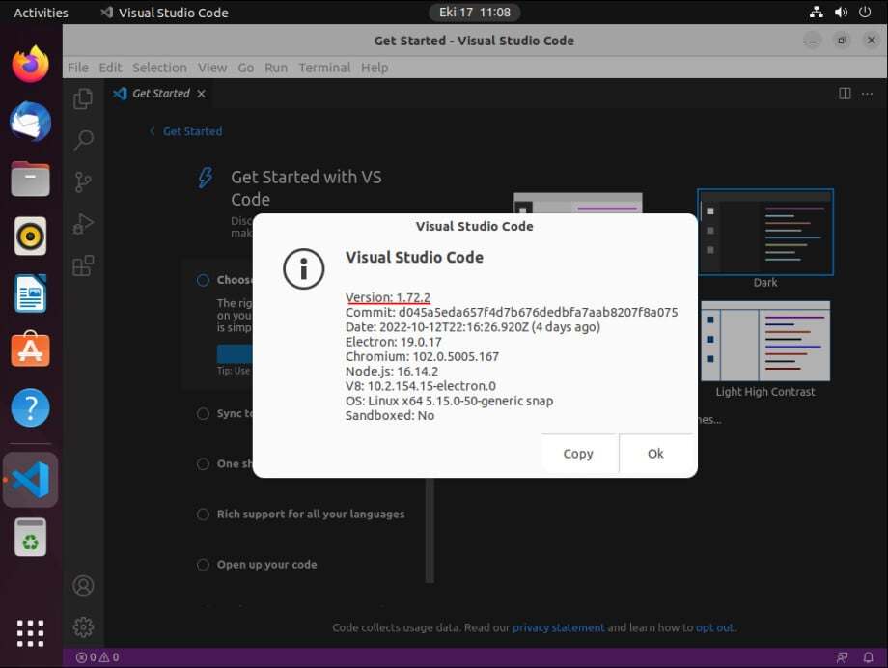

Installation completed successfully without using terminal.

**Method-2: Installing .deb Package Manually**

[Download the debian package for Visual Studio Code](https://go.microsoft.com/fwlink/?LinkID=760868). In our example, the file was downloaded to /home/foc/Downloads:

bash

foc@ubuntu22:~/Downloads$ pwd

/home/foc/Downloads

foc@ubuntu22:~/Downloads$ ls

code_1.72.2-1665614327_amd64.deb

Then the downloaded package is installed with the following command:

bash

foc@ubuntu22:~/Downloads$ sudo dpkg -i code_1.72.2-1665614327_amd64.deb

Selecting previously unselected package code.

(Reading database ... 198274 files and directories currently installed.)

Preparing to unpack code_1.72.2-1665614327_amd64.deb ...

Unpacking code (1.72.2-1665614327) ...

Setting up code (1.72.2-1665614327) ...

Processing triggers for mailcap (3.70+nmu1ubuntu1) ...

Processing triggers for gnome-menus (3.36.0-1ubuntu3) ...

Processing triggers for desktop-file-utils (0.26-1ubuntu3) ...

Processing triggers for shared-mime-info (2.1-2) ...

*Hint:* If it gives a package dependency error during installation, run the following command. It will install the missing dependencies.

bash

$ sudo apt-get install -f

The package was installed and also the vscode.list file was created under the /etc/apt/sources.list.d directory. It will now also make updates from this repository.

bash

foc@ubuntu22:~/Downloads$ ls /etc/apt/sources.list.d/

vscode.list

Repository file contents:

bash

foc@ubuntu22:~/Downloads$ cat /etc/apt/sources.list.d/vscode.list

### THIS FILE IS AUTOMATICALLY CONFIGURED ###

# You may comment out this entry, but any other modifications may be lost.

deb [arch=amd64,arm64,armhf] http://packages.microsoft.com/repos/code stable main

After this step, you can use Visual Studio Code by typing code from the menu.

**Method-3: Install VSC Package from the Repository**

When we installed the Visual Studio Code debian (.deb) package, the key and the repository file were automatically installed by the system. You can also do this by first installing the repository and the key, then installing a package.

Advertisement

First install the package dependencies:

bash

foc@ubuntu22:~$ sudo apt install wget gpg -y

Upload the repository key to the system:

bash

foc@ubuntu22:~$ wget -qO- https://packages.microsoft.com/keys/microsoft.asc | gpg --dearmor > packages.microsoft.gpg

foc@ubuntu22:~$ sudo install -D -o root -g root -m 644 packages.microsoft.gpg /etc/apt/keyrings/packages.microsoft.gpg

Create the repository file:

bash

foc@ubuntu22:~$ sudo sh -c 'echo "deb [arch=amd64,arm64,armhf signed-by=/etc/apt/keyrings/packages.microsoft.gpg] https://packages.microsoft.com/repos/code stable main" > /etc/apt/sources.list.d/vscode.list'

File created under /etc/apt/sources.list.d/ directory.

bash

foc@ubuntu22:~$ ls /etc/apt/sources.list.d/

vscode.list

Delete the .gpg file:

bash

foc@ubuntu22:~$ rm -f packages.microsoft.gpg

Update the package list:

Advertisement

bash

foc@ubuntu22:~$ sudo apt update -y

Install the code package:

bash

foc@ubuntu22:~$ sudo apt install code -y

Reading package lists... Done

Building dependency tree... Done

Reading state information... Done

The following package was automatically installed and is no longer required:

systemd-hwe-hwdb

Use 'sudo apt autoremove' to remove it.

The following NEW packages will be installed:

code

0 upgraded, 1 newly installed, 0 to remove and 158 not upgraded.

Need to get 88,1 MB of archives.

After this operation, 369 MB of additional disk space will be used.

Get:1 https://packages.microsoft.com/repos/code stable/main amd64 code amd64 1.72.2-1665614327 [88,1 MB]

Fetched 88,1 MB in 46s (1.925 kB/s)

Selecting previously unselected package code.

(Reading database ... 198273 files and directories currently installed.)

Preparing to unpack .../code_1.72.2-1665614327_amd64.deb ...

Unpacking code (1.72.2-1665614327) ...

Setting up code (1.72.2-1665614327) ...

Processing triggers for gnome-menus (3.36.0-1ubuntu3) ...

Processing triggers for shared-mime-info (2.1-2) ...

Processing triggers for mailcap (3.70+nmu1ubuntu1) ...

Processing triggers for desktop-file-utils (0.26-1ubuntu3) ...

The package has been installed, the files belonging to the package have been uploaded to the system. You can access Visual Studio Code by typing code from the menu.

With this method, package updates are automatically received after installation.

**Method-4: Download “.tar.gz” for Visual Studio Code**

This method is always applied when there is no access to the package repositories. You can use the tar.gz file from anywhere by taking it to a portable memory.

Now download the file by going to the Visual Studio Code o[fficial download address](https://code.visualstudio.com/download):

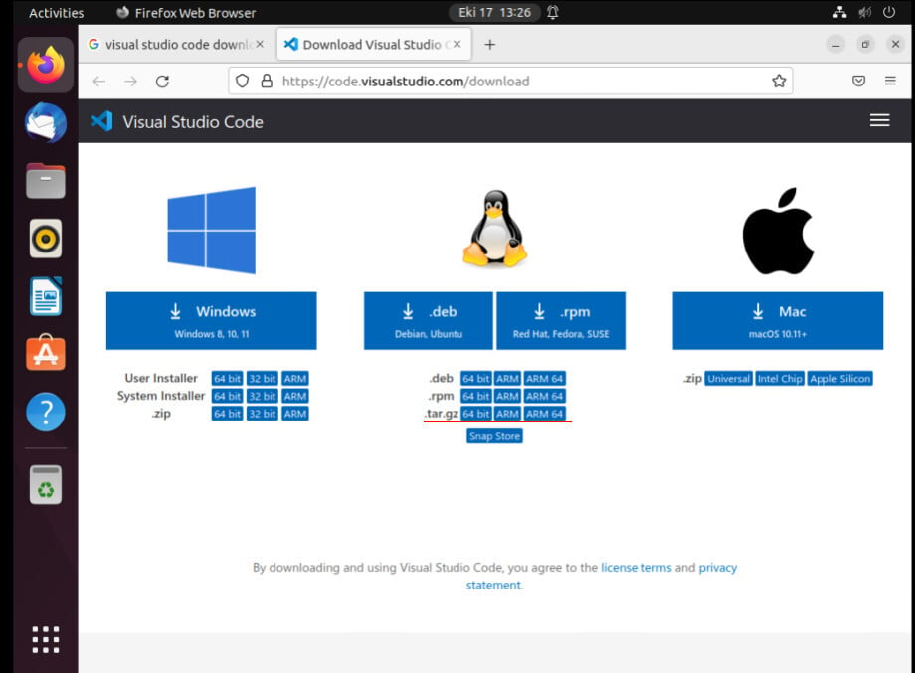

Right-click on the downloaded compressed file, click **Extract Here**.

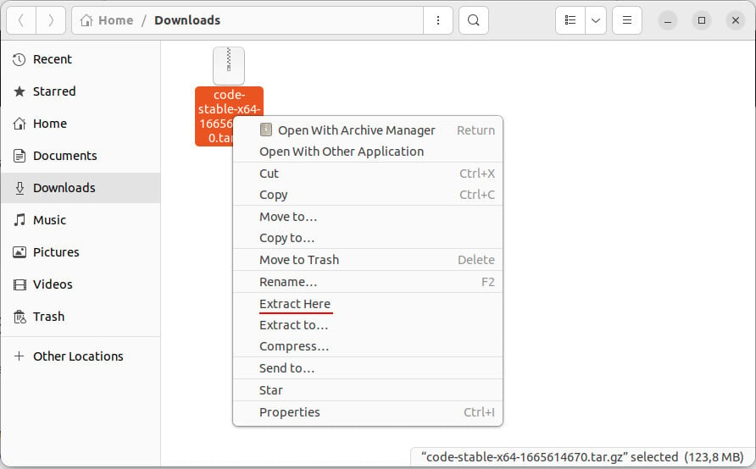

Right click on executable **code** file --> run or double click with mouse.

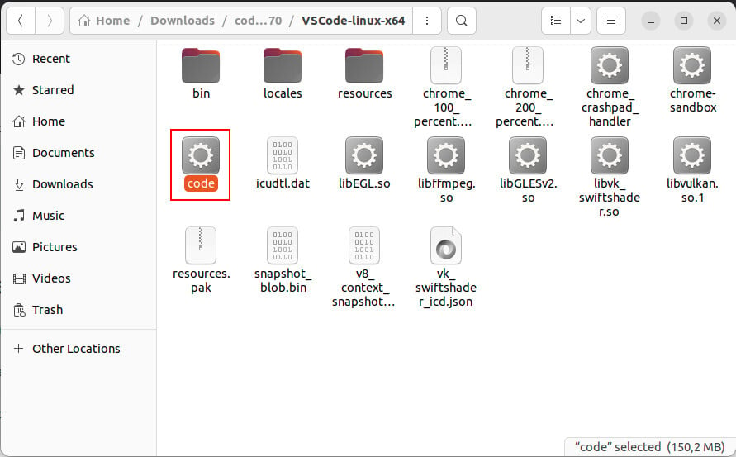

With this method, Visual Studio Code installation is completed.

